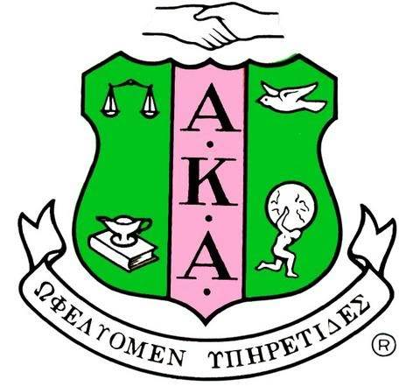
Graduate Advisory Committee Report
September 10, 2018

Members of Graduate Advisor Council
- Soror Sallie E. Brown - Graduate Advisor
- Soror Sobande Afolabi
- Soror Cimeron Bryant

Members of Tau Sigma
- Soror Taylor Higgins
- Soror Nadi Sundal

Goals for Graduate Advisor Council
- Establish open and effective line of communication with Tau Sigma
- Setup chapter operations workshops for Tau Sigma
- Establish mentorship program with Tau Sigma
- Review Tau Sigma Chapter documents, governance and structure

Greek Recognition Packet was submitted to Dr. Lyn Hamlin, Dean of Students at New Jersey City University on September 11, 2018. The 2018 Certificate of Liability Insurance and letter of Good Standing from Regional Director are still needed. Once the documents are obtained they will be provided to the Dean.

Tau Sigma needs a Campus Advisor. Dr. Regina Adesanya expressed an interest in the position. Soror Sallie E. Brown will be meeting with her on September 19, 2018 to discuss the role of the position and expectations.

GAC discussed how to help rebuild Tau Sigma and what Tau Sigma needs from Rho Kappa Omega to help support them

Team building activities will be implemented to improve the relationship with Tau Sigma and Rho Kappa Omega

The Graduate Advisor Council will meet the first Wednesday of each month at 7:30pm. The next meeting will take place on October 3, 2018.

Respectfully submitted,
Soror Sallie E. Brown
Graduate Advisor

