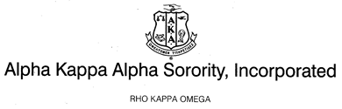
Sisterly Relations Committee
September 2018 Report

- The Sisterly Relations Committee hosted a Sisterly Game night on Friday, September 7, 2018 at 7pm at 60 Parkway Drive East Orange, NJ. Nine sorors were in attendance and the evening was filled with fun, laughter and sisterly bonding.

- On Wednesday, September 12, 2018 a conference call was held to discuss the 30th Anniversary celebration. There were six sorors on the conference call.

The following items were discussed and confirmed.
30th Anniversary Celebration
- Date: Saturday, September 22nd (directly after Undergraduate Round Up)

- Location:
Aja Asian Cuisine & Lounge
Address: 28 US-1
New Brunswick, NJ 08901
Phone: (732) 249-5888
http://www.aja-newbrunswick.com/

Please note: The restaurant can split up to seven checks

- Time: 5pm

- Theme: Pearl

- Budget/Cost: Sorors will pay for their own meals/drinks

- Committee will only cover cost of frames and decorations

Respectfully Submitted,
Soror Vanessa Jean-Louis
Chairman

